D. Y. Patil Agriculture and Technical University, Talsande .

PROJECT NAME:
Uncovering the Hidden Treasures of the Mushroom Kingdom: A Classification Analysis

STUDENT INFORMATION:
STUDENT NAME: Prajkta Raghunath Ghodake
CLASS: B.Tech AIML
DIV: A
ROLL NO: 34
PRN NO: 2022011011016

TABLE OF CONTENTS

CHAPTER NO. TITLE PAGE NO.

- INTRODUCTION 1
  - Project Overview 1
  - Purpose
  - Objectives of the Project
1.4 Tools and Technologies Used
1.5 Dataset Collection and Organization

2 8
- REQUIREMENT ANALYSIS 9
  - Functional requirement 9
  - Non-Functional requirements 10
- PROJECT DESIGN 11
  - Data Flow Diagrams 11
  - Solution & Technical Architecture 11
- CODING & SOLUTIONING 13
  - Feature 1 13
  - Feature 2 16
- ADVANTAGES & DISADVANTAGES 25
- CONCLUSION 26
- FUTURE SCOPE 27
- APPENDIX 28

CHAPTER 1 INTRODUCTION

Project Overview:
This project aims to classify different species of mushrooms based on their images. The classification is done using deep learning methods, specifically transfer learning using popular models Inception. The focus is on identifying the cap, gills underside of cap, and astern, which are key features for the optical recognition of mushroom species. The identified species are Boletus, Lactarius, and Russula.
The classification task involves three major categories of mushrooms: Boletus, Lactarius, and Russula. These categories encompass a wide range of species found across different regions of our planet. Boletus mushrooms are known for their distinctive cap shapes and pore-covered undersides, while Lactarius mushrooms often exhibit vibrant colors and produce a milky latex when damaged. Russula mushrooms, on the other hand, showcase diverse cap and stem characteristics and are an intriguing group to explorewhich are found in various habitats like forests, fields, and decomposing logs. Mushrooms have different shapes, sizes, and colors and are used for food, medicine, and other purposes. By leveraging deep learning techniques and transfer learning, this project aims to improve the accuracy and efficiency of mushroom species classification.

Purpose :
The purpose of this project is to develop a robust and accurate system for optical recognition and classification of mushroom species based on their visual characteristics. By leveraging deep learning techniques and transfer learning, this project aims to enhance the efficiency and accuracy of mushroom species identification. The project not only contributes to the field of mycology but also holds ecological significance by aiding in the study and conservation of mushroom species. Additionally, the system has practical applications in culinary and medicinal domains, enabling the identification of edible and medicinal mushrooms. Overall, this project serves as a comprehensive exploration of deep learning and transfer learning methods in the context of mushroom species recognition, showcasing their potential in image analysis and classification tasks.

1.3 Objectives of the Project

The key objectives of this project are:

• To understand image preprocessing and data augmentation techniques.

• To apply transfer learning using the Xception architecture.

• To build a classification model for mushroom species.

• To evaluate model performance using accuracy metrics.

• To integrate the trained model into a Flask web application.

• To provide a user-friendly interface for real-time image prediction.

1.4 Tools and Technologies Used

Google Colab:
Google Colab provides a cloud-based Jupyter notebook environment with free GPU access, making it ideal for deep learning model training.

Python Libraries:
NumPy – Used for numerical computations and array manipulation.
Pandas – Used for structured data handling (if required).
Matplotlib – Used for visualization of training results.
TensorFlow and Keras – Used for implementing deep learning models.
Flask – Used for deploying the trained model as a web application

1.5 Dataset Collection and Organization

The dataset consists of mushroom images categorized into three classes:
1. Boletus
2. Lactarius
3. Russula

The dataset is organized into training and testing folders as follows:

Dataset/
├── train/
│ ├── Boletus/
│ ├── Lactarius/
│ └── Russula/
└── test/
├── Boletus/
├── Lactarius/
└── Russula/

This folder structure allows the ImageDataGenerator class to automatically assign labels based on directory names.

CHAPTER 2

REQUIREMENT ANALYSIS

Functional Requirement :

FR No. | Functional Requirement (Epic) | Sub Requirement (Story / Sub-Task)
FR-1 | User Registration | Allow users to register an account.
FR-2 | User Confirmation | Send confirmation email to verify user’s registration.
FR-3 | Mushroom Classification | - Implement deep learning algorithms for mushroom analysis.  - Use transfer learning techniques( inception V3, resnet50V2, Xception)  - Train the models to classify mushrooms into Boletus, Lactarius, and Russula categories
FR-4 | Image Processing | Develop image processing module to extract features from mushroom images.
FR-5 | Prediction and Classification | Perform prediction and classification of mushrooms based on the trained models
FR-6 | User Interface | Design a user friendly interface for users to interact with the system

2.2 Non-Functional Requirement :

FR No. | Non-Functional Requirement | Description
NFR-1 | Usability | The system should be intuitive and easy to use for both technical and non-technical users.
NFR-2 | Security | Implement security measures to protect user data and prevent unauthorized access.
NFR-3 | Reliability | Ensure the system is stable and reliable, with minimal downtime or errors.
NFR-4 | Performance | The system should have fast processing and response times for image classification.
NFR-5 | Availability | The system should be available for users to access and use at all times.
NFR-6 | Scalability | The system should be able to handle a growing number of users and mushroom images efficiently.

CHAPTER 3 PROJECT DESIGN

3.1 Data Flow Diagrams :
A Data Flow Diagram (DFD) is a traditional visual representation of the information flows within a system. A neat and clear DFD can depict the right amount of the system requirement graphically. It shows how data enters and leaves the system, what changes the information, and where data is stored.
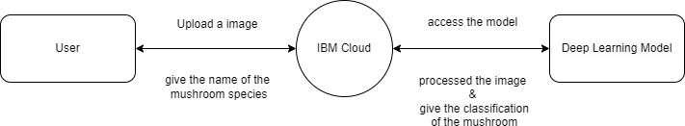

3.2 Solution & Technical Architecture :

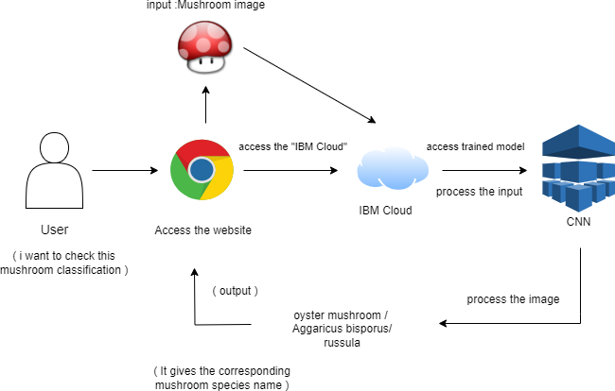
11

CHAPTER 4

CODING & SOLUTIONING

PROJECT STRUCTURE :

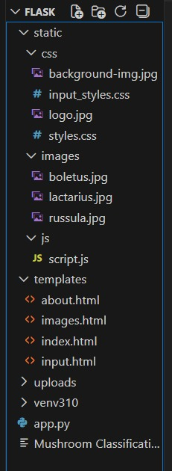
Uncovering the Hidden Treasures of the Mushroom Kingdom: A Classification Analysis Project structure, it have the static(css,js), templates(HTML),uploads,app.py file and transfer learning model.

4.1 Feature 1 :
Uncovering the Hidden Treasures of the Mushroom Kingdom: A Classification Analysis Project has function that user uploads any mushroom image it will give the classification of the mushroom, with their family name like “Boletus, Lactarius & Russula.”

Coding :
Importing required libraries
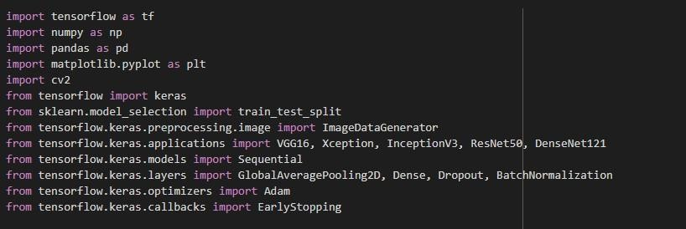
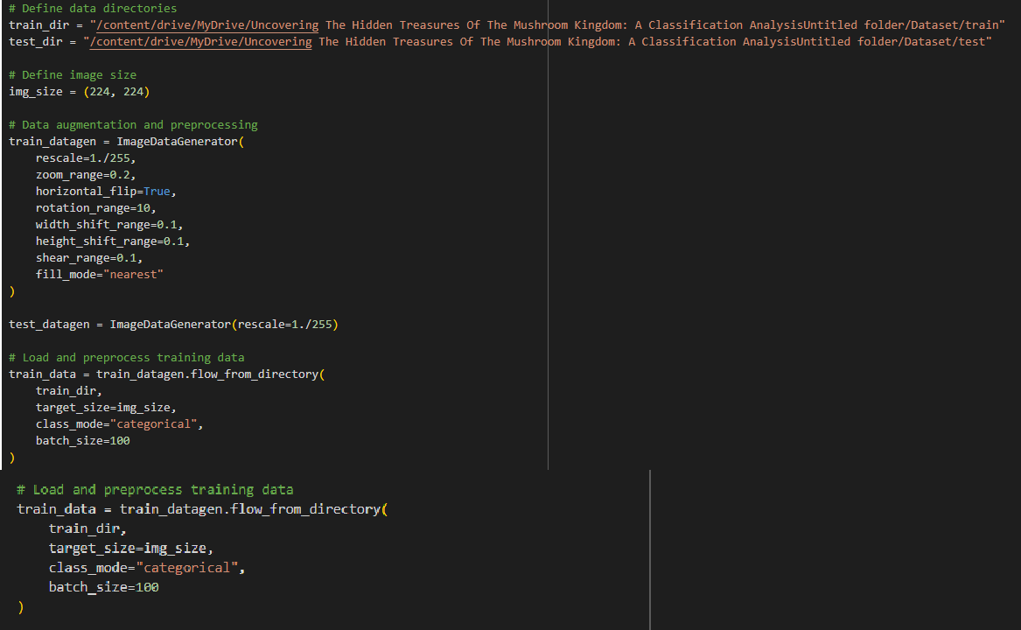
Define dataset directory and data augmentation

Model building with InceptionV3 pretrained model, adding layer & Training the model :
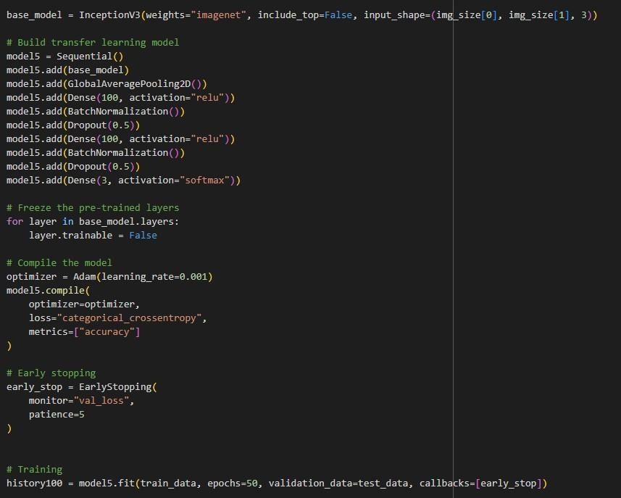

This model is build with pretrained model “InceptionV3” and adding the layers like 3 dense layers , GlobalAveragePooling2D. A Dense layer with 100 units and ReLU activation function is added. BatchNormalization layer is added to normalize the activations of the previous layer.
Dropout layer is added to prevent overfitting by randomly dropping 50% of the connections.
A Dense layer with 3 units and softmax activation function is added as the final output layer.

Predicting the input image :

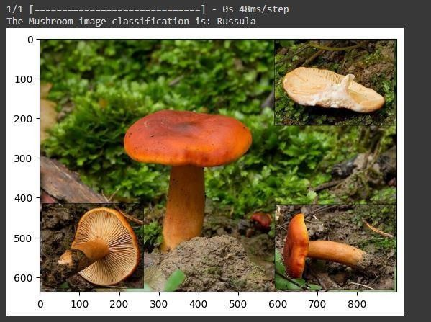
If user upload image, the model will classify the images then process the image and give the mushroom classification (Output).

4.1 Feature 2 :
In Existing projects it doesn’t show the upload file, but our project overcome it .We integrated Machine learning to flask. Flask is a webFramework development.
Uncovering the Hidden Treasures of the Mushroom Kingdom: A Classification Analysis Project structure, it have the static(css,js), templates(HTML),uploads,app.py file and transfer learning model.

Flask App :
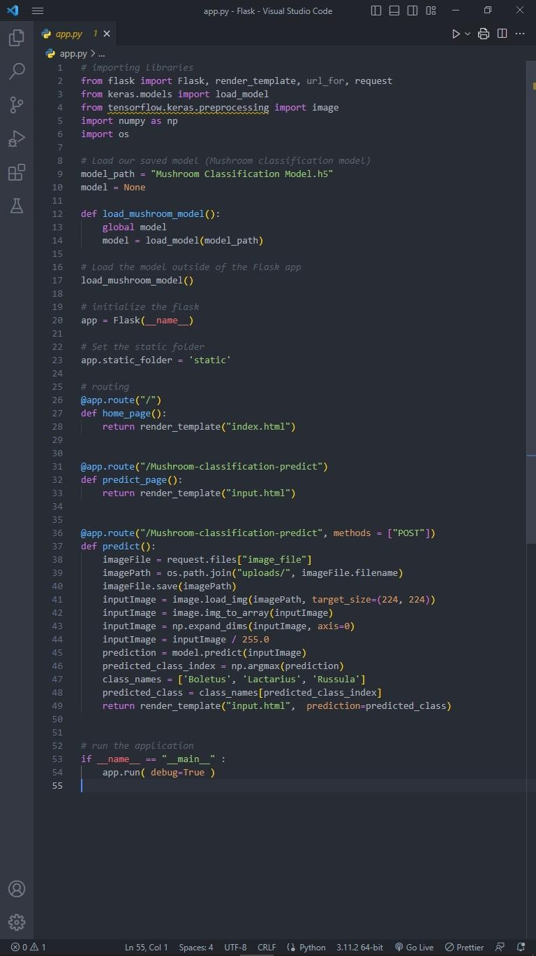
17

index.html :
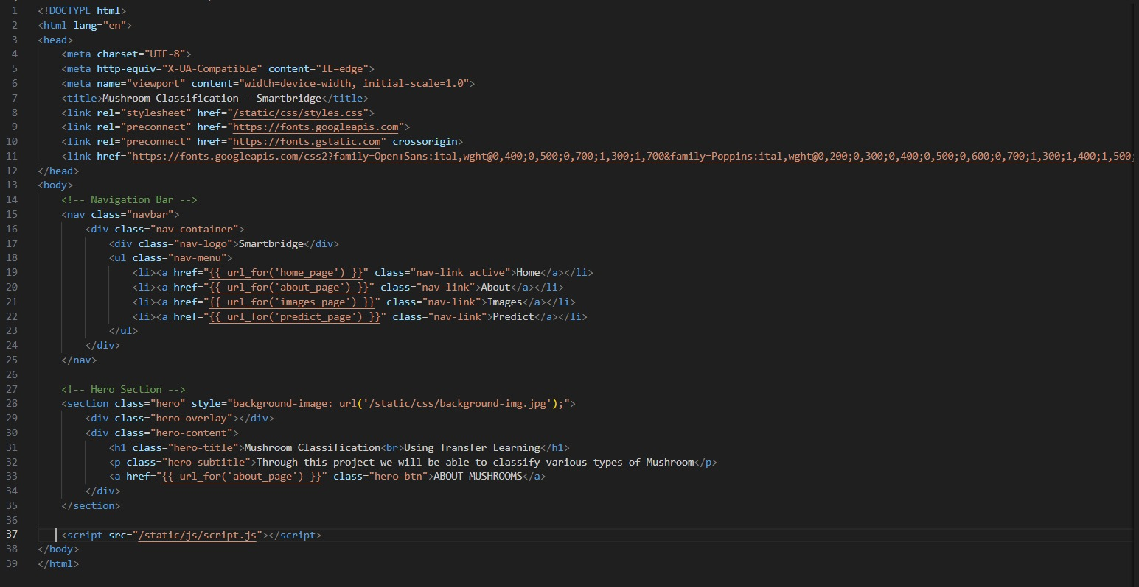
input.html :

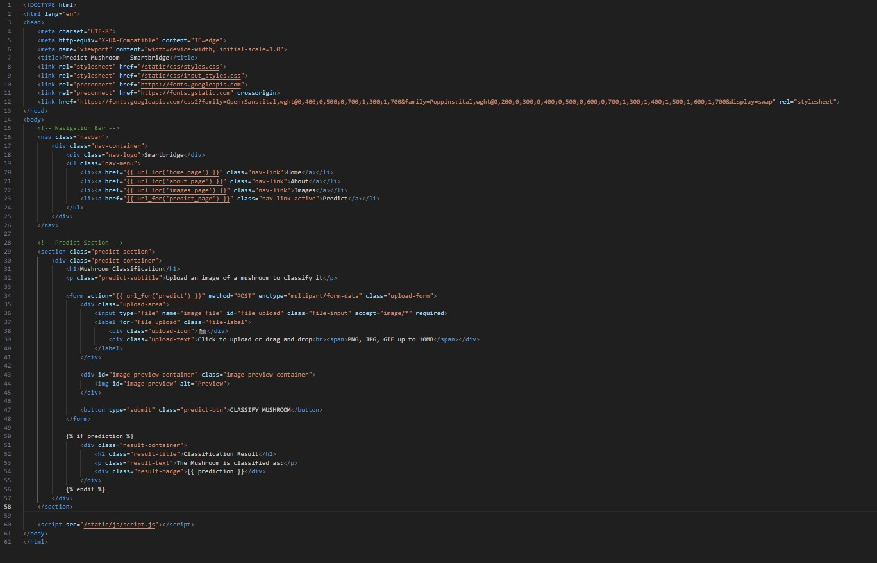

18

TESTING :

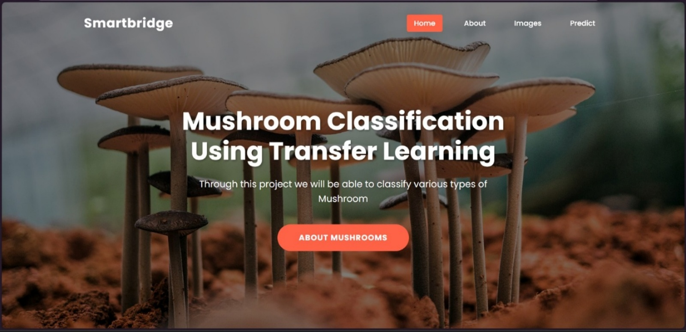

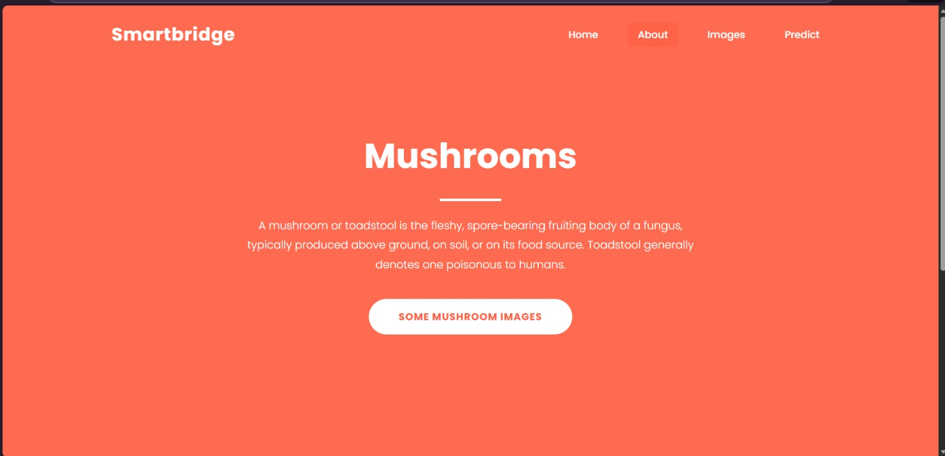

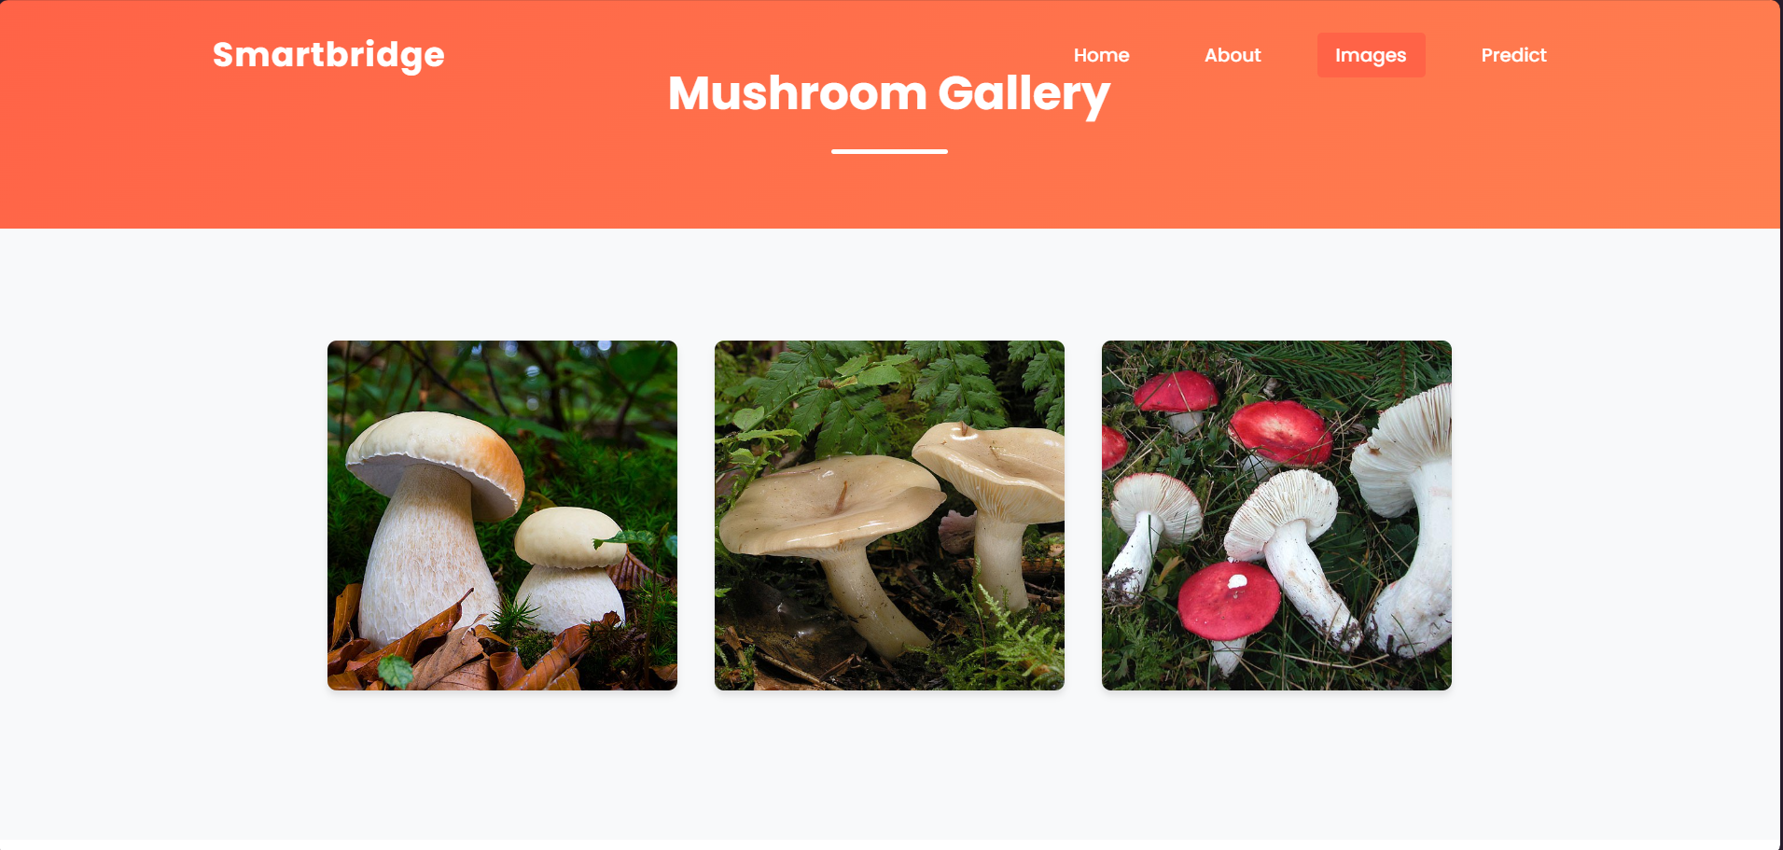

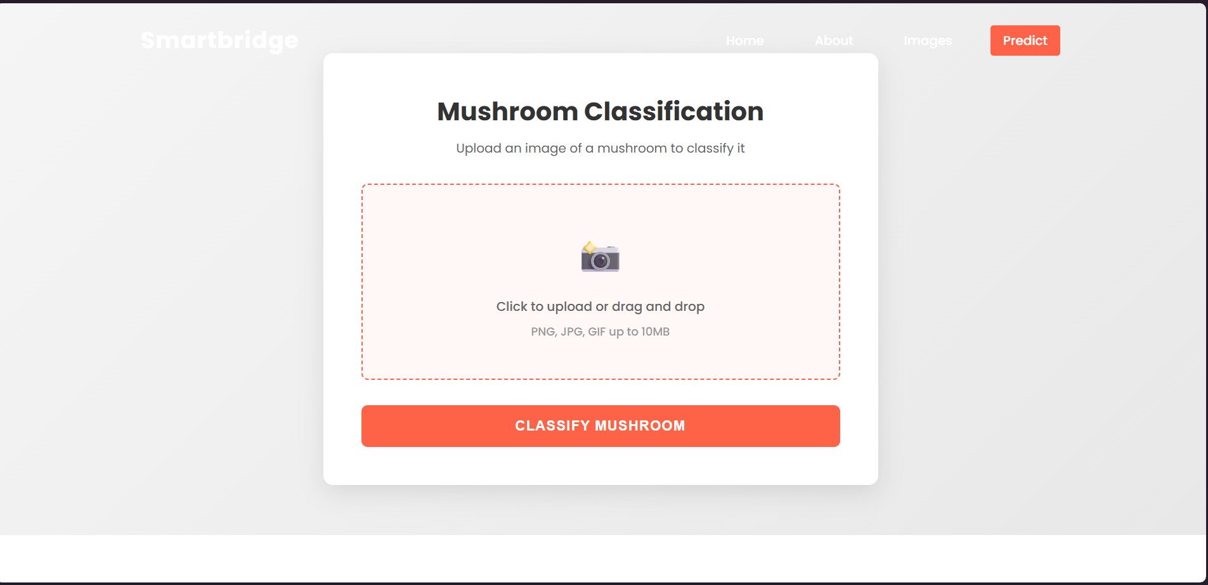

The interface of the Uncovering the Hidden Treasures of the Mushroom Kingdom: In UI you can see the buttons like Home, About, Images, Predict.

SELECT IMAGE :

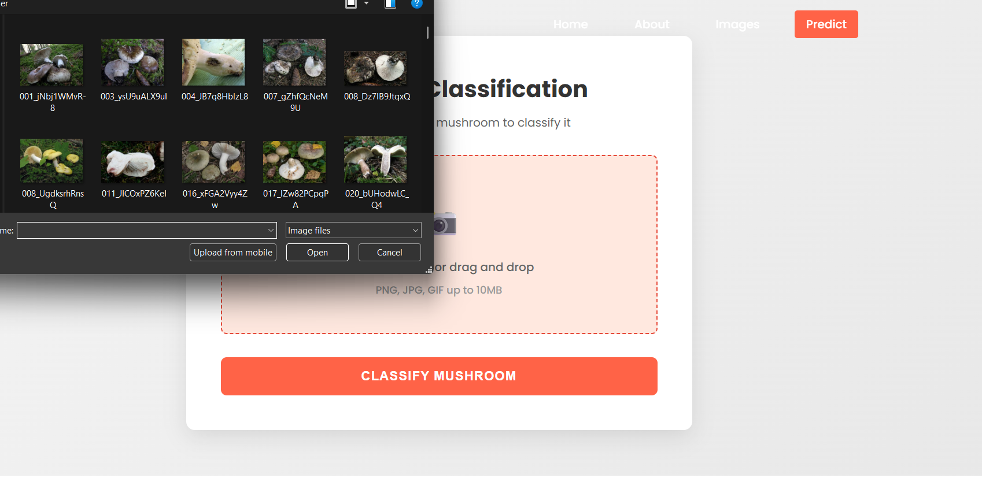

OUTPUT PAGE :

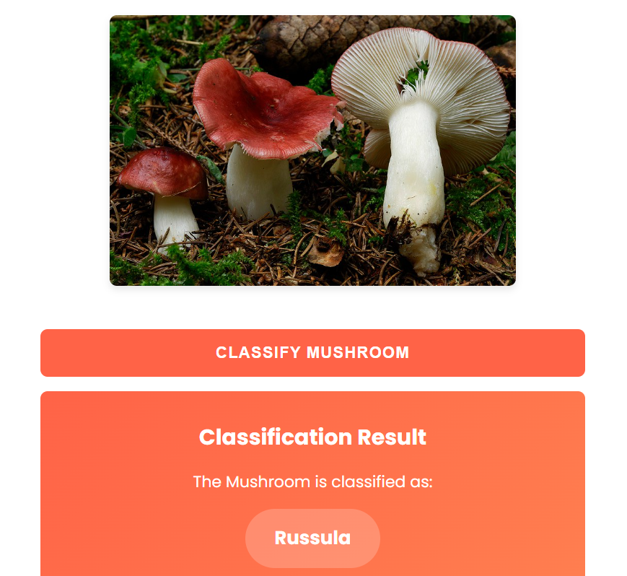

CHAPTER 5 ADVANTAGES & DISADVANTAGES

ADVANTAGES :

- Good User – Friendly interface
- Less complexity
- Optical recognition
- High-performance classifiers: Deep-learning methods (InceptionV3)
- Wide range of mushrooms image classification
- High speed mushroom image classification
- Useful for all kind of peoples

DISADVANTAGES :

- Less accessibility
- Limited scope ( Classifies only 3 kinds of mushrooms only ).

CHAPTER 6

CONCLUSION
In conclusion, the project focused on the optical recognition and classification of various mushroom species using deep-learning methods. By leveraging transfer learning techniques and Inception V3 model, the project aimed to achieve high-performance classification accuracy. The classification of mushrooms has a wide range of applications, including food, medicine, conservation, and ecological research. By accurately identifying mushroom species based on their physical features, The project also contributes to the advancement of mycology as a scientific discipline and enthusiasts.

CHAPTER 7
FUTURE SCOPE
- Future Enhancements

Future improvements may include:
• Expanding the dataset with more mushroom species.
• Fine-tuning deeper layers of the Xception model.
• Deploying the application on cloud platforms.
• Improving UI design for better user experience.
• Integrating mobile compatibility.

Overall, the project successfully fulfills its objectives and demonstrates a complete machine learning pipeline from data collection to deployment.

CHAPTER 8 APPENDIX

Source Code :

GitHub & Project Video Demo Link :

Git Repo Link :

Project Demo Link :
( Demonstration video )

